
K4 CSF3133 REKA BENTUK ANTARA MUKA BERASASKAN WEB
LAB REPORT 8
SEMESTER 3

PREPARED FOR: ASSOC. PROF. TS. DR. WAN NURAL JAWAHIR
LAB ASSISTANT: MISS WAN FATIN

PREPARED BY: AKMA ASYIFA BINTI ZULKARNAIE
NO. MATRIC: S75186
SUBMISSION DATE: 17 DECEMBER 2025

LAB 8: BOOTSTRAP
8.3 Create First Web Page with Bootstrap
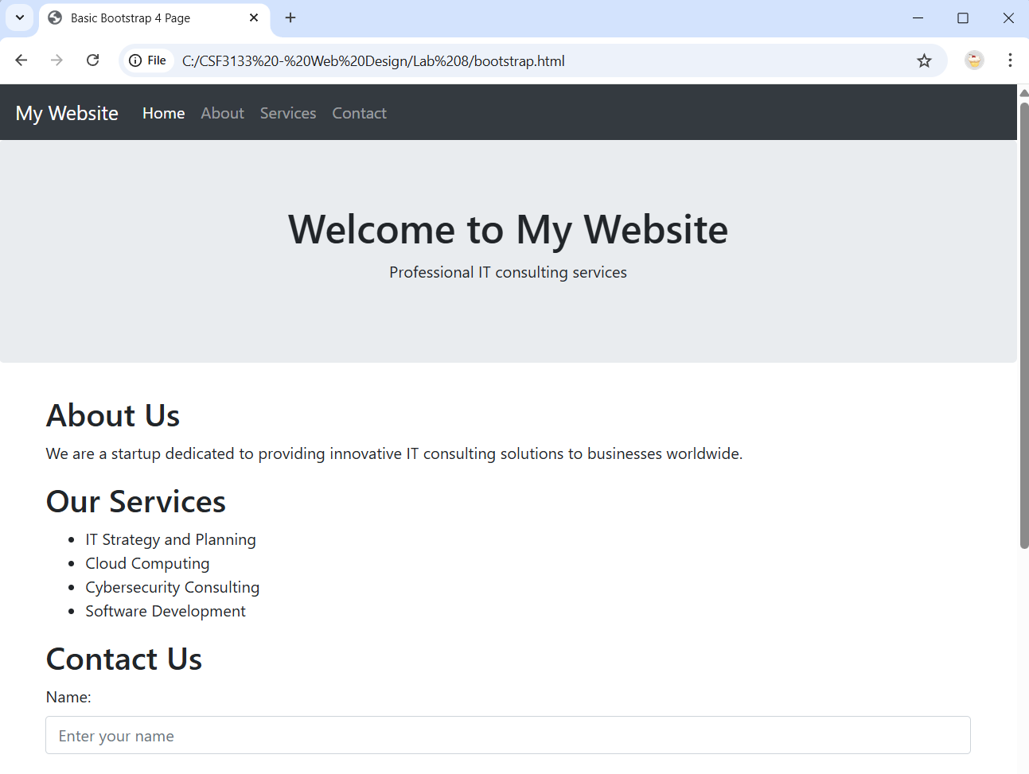
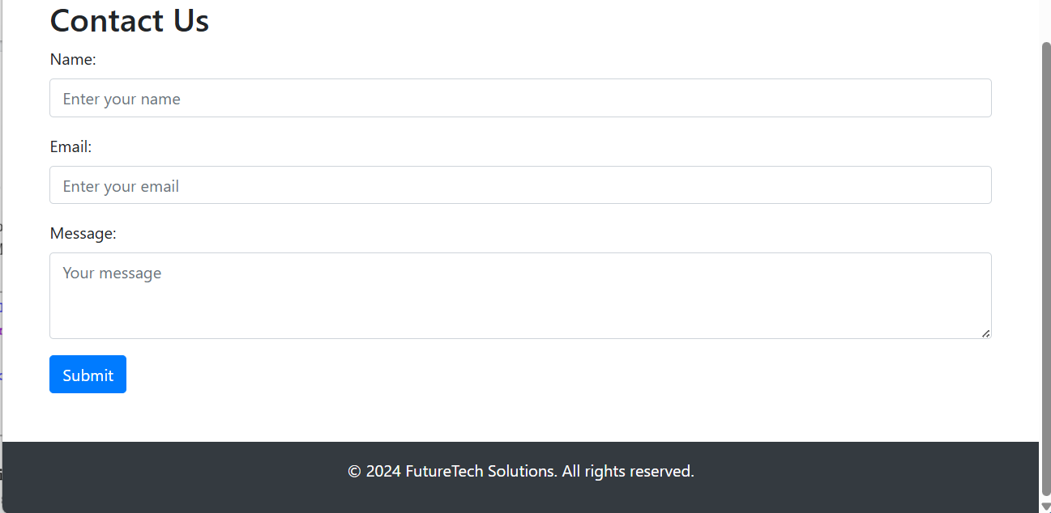
8.4 Responsive Image
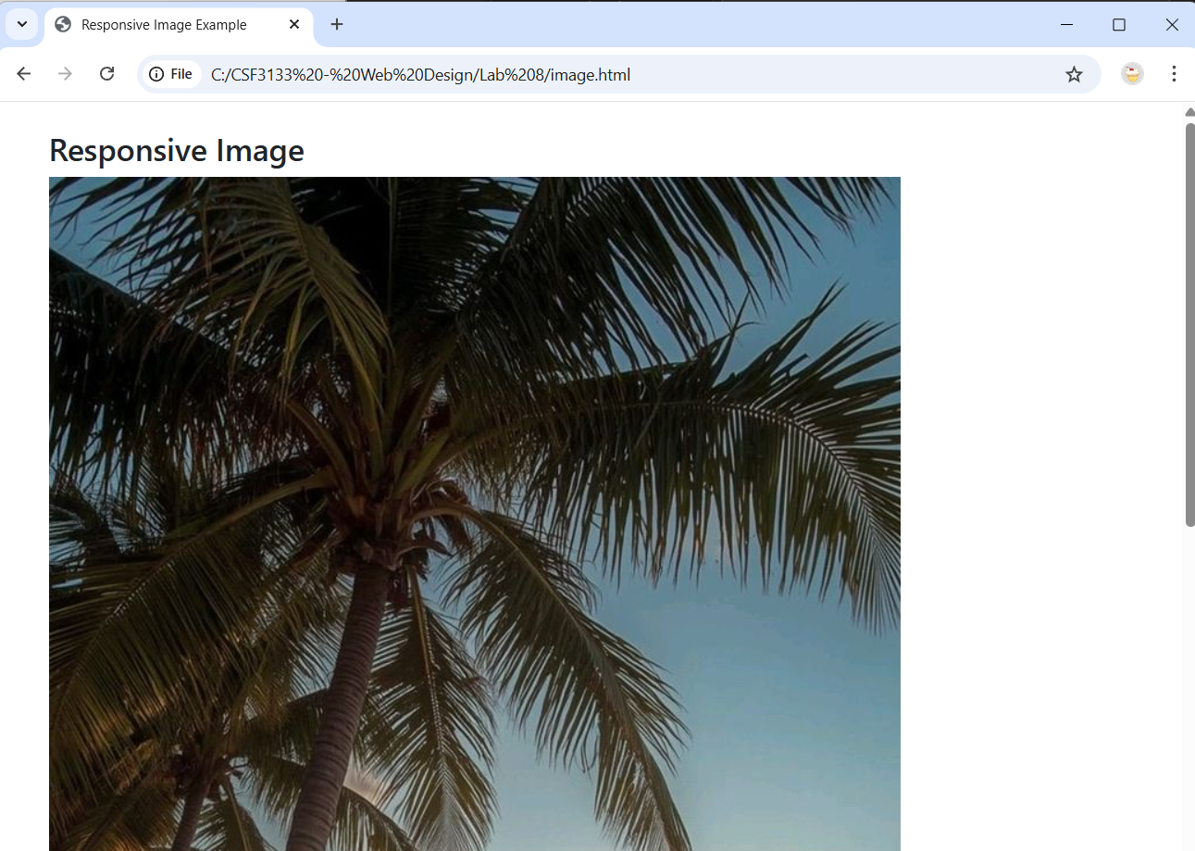
8.5 Bootstrap Text/Typography
8.5.1 Headings
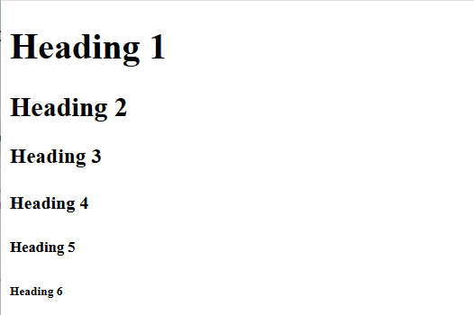
8.5.2 Display Headings
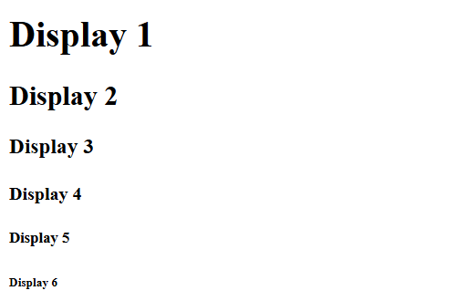
8.5.3 Inline Text Elements
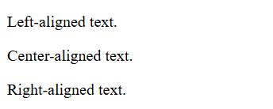
8.5.4 Text Color and Background
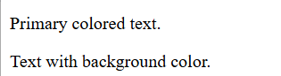

8.5.5 Text Wrapping and Overflow
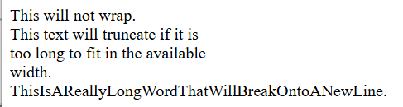
8.5.6 Font size
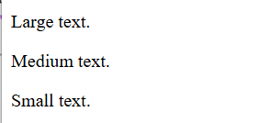
8.5.7 Font Weight and Style
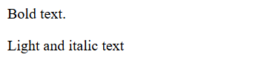
8.5.8 Line Height

8.5.9 Lists
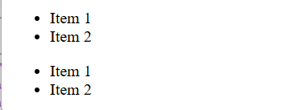
8.6 Bootstrap CSS Forms
8.6.1 Basic Form Structure
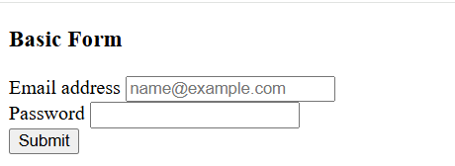

8.6.2 Form Layouts
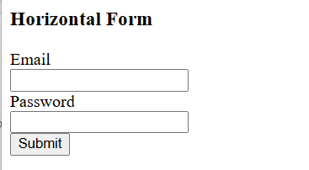
8.6.3 Inline Form
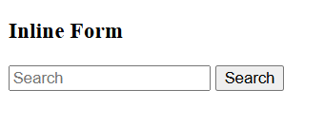
8.6.4 Form Controls
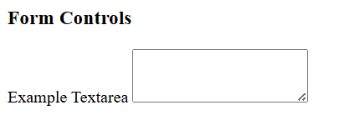
8.6.5 Select Menus
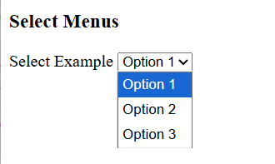
8.6.6 Form validations
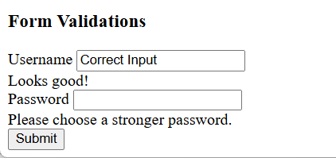
8.6.7 Checkboxes and Radios
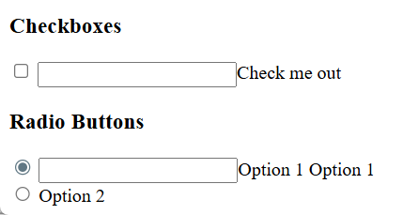
8.6.8 Input Groups
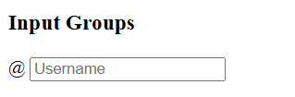
8.6.9 Floating labels
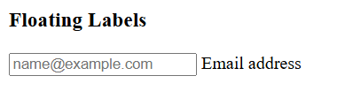
8.6.10 Disabled and Readonly Inputs
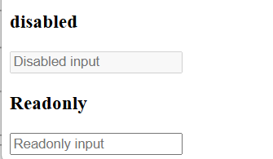
8.6.11 Example Forms
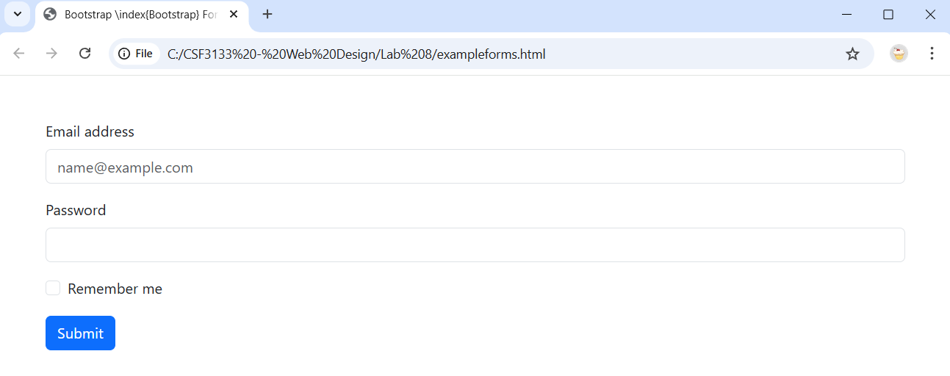

8.7 Using Bootstrap Theme
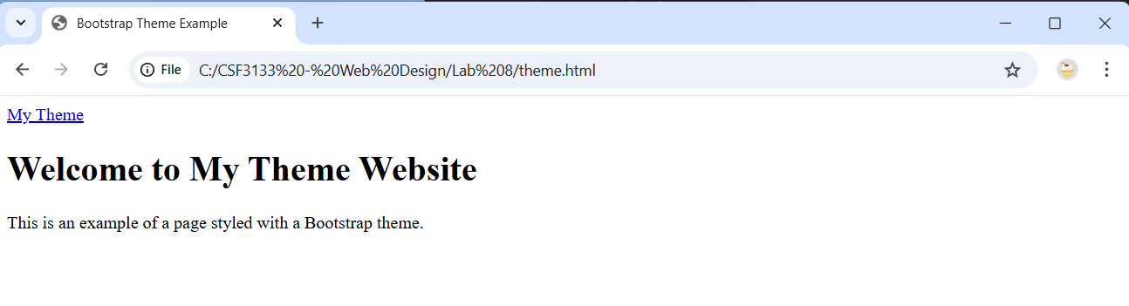
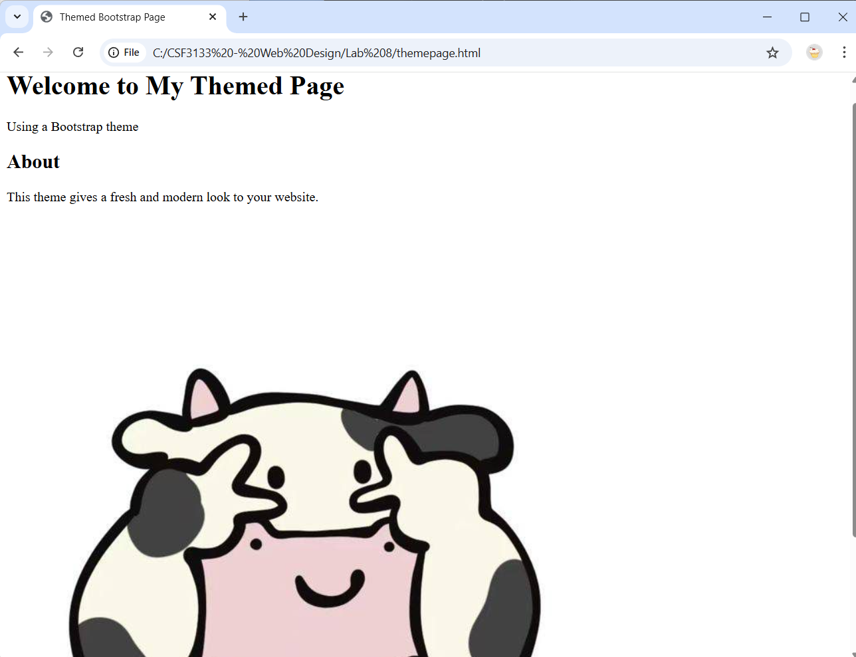

LAB EXERCISES 8
Homepage.html
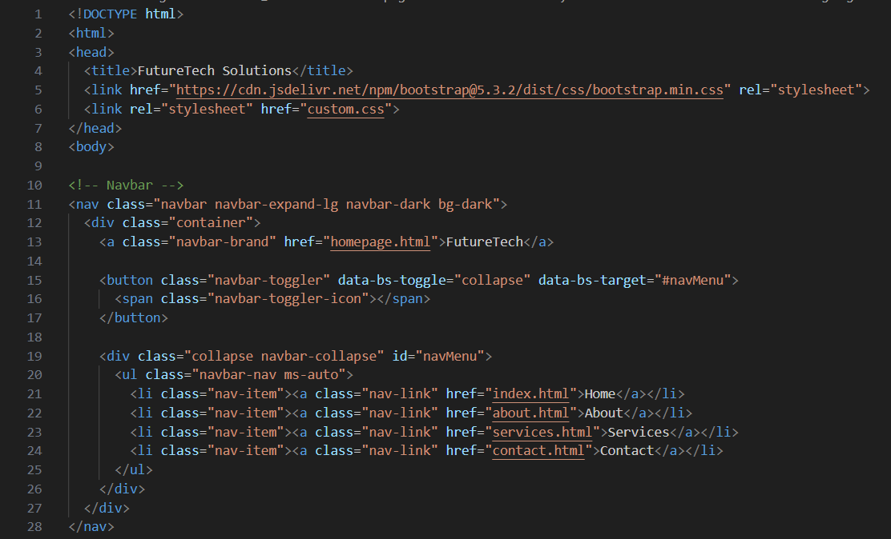
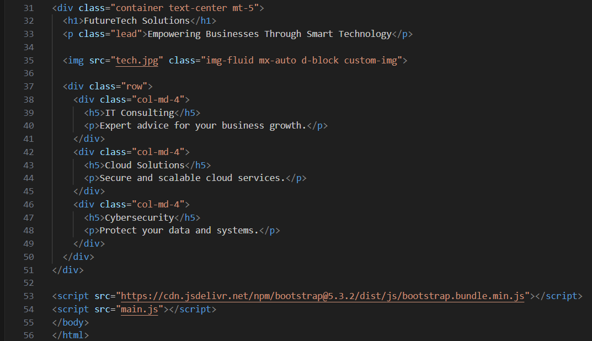
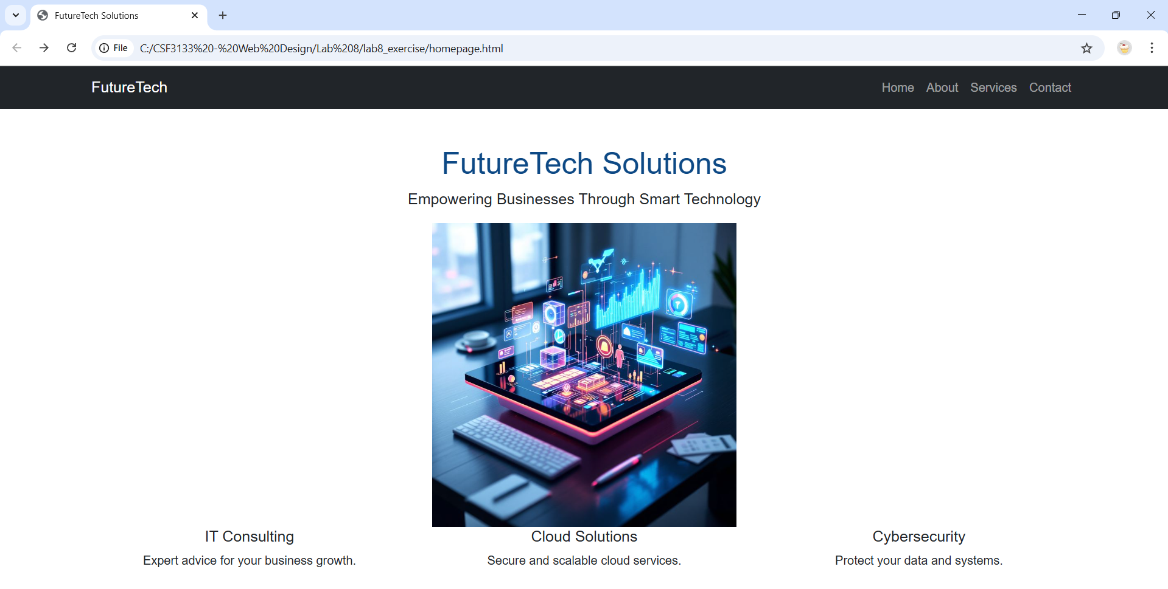

About.html
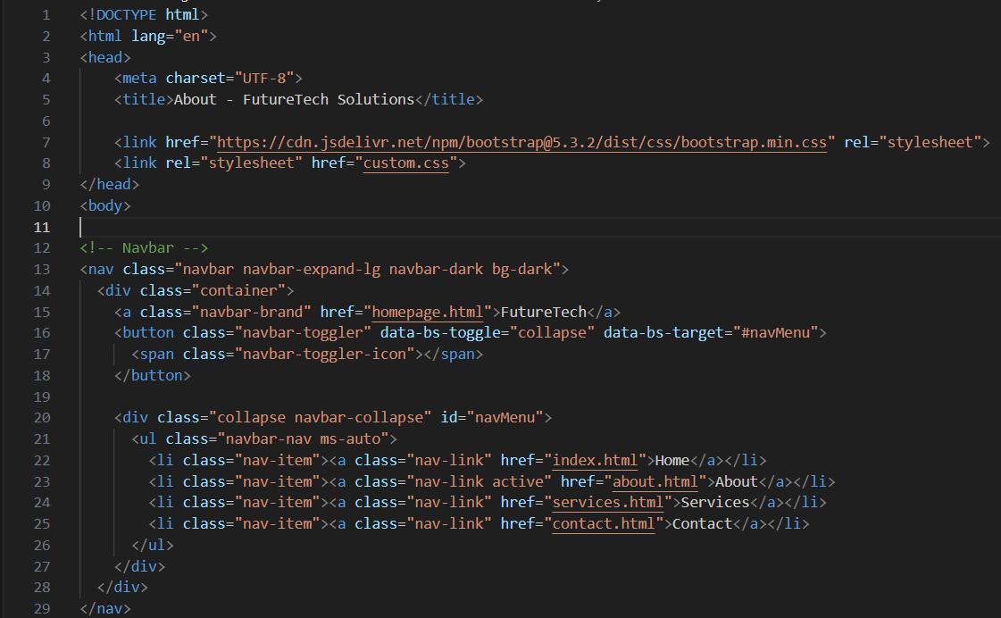
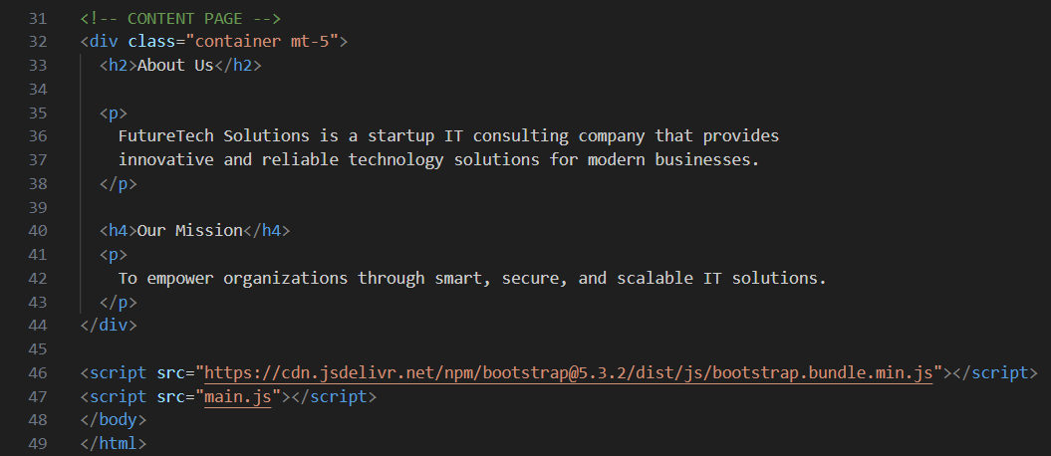
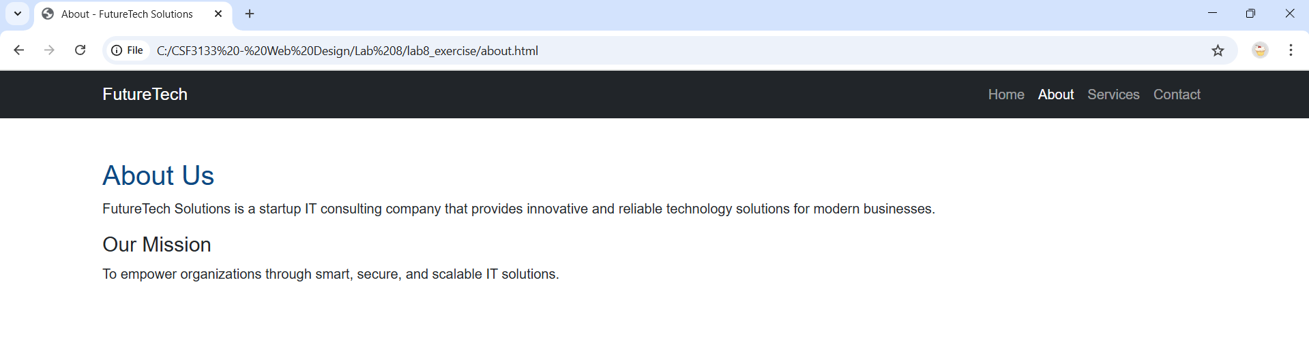
Services.html
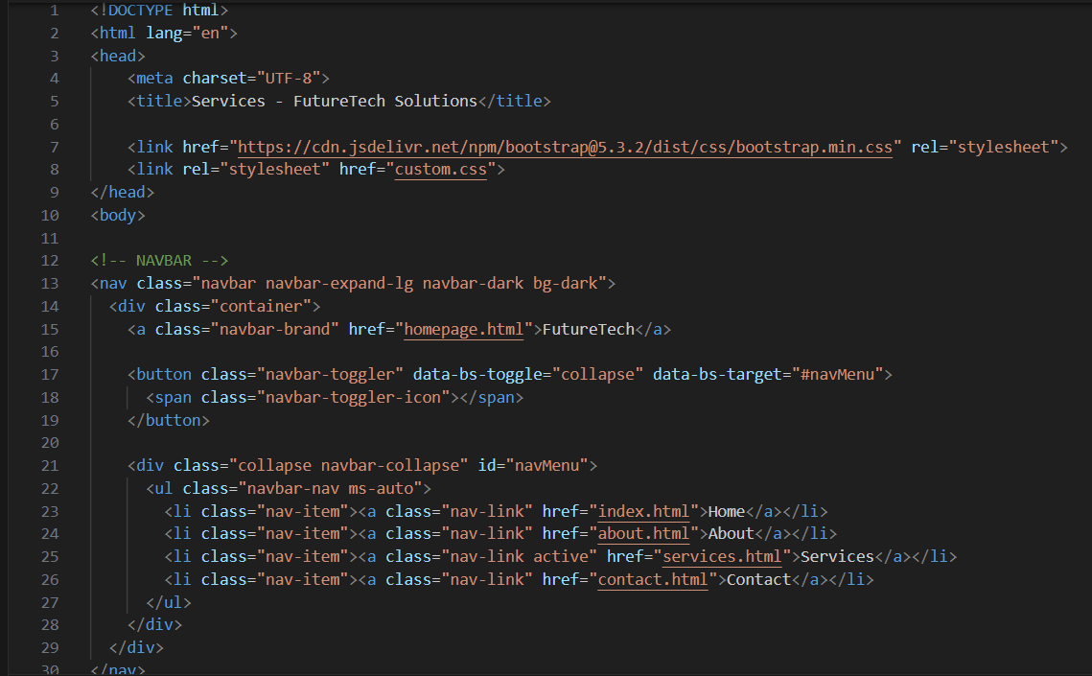
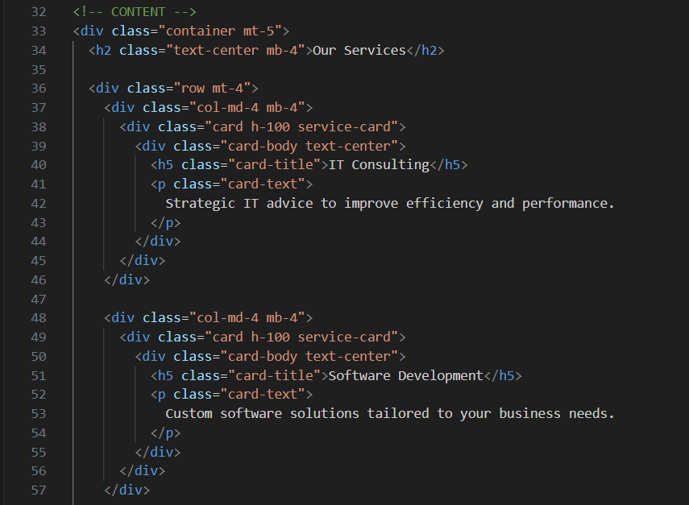
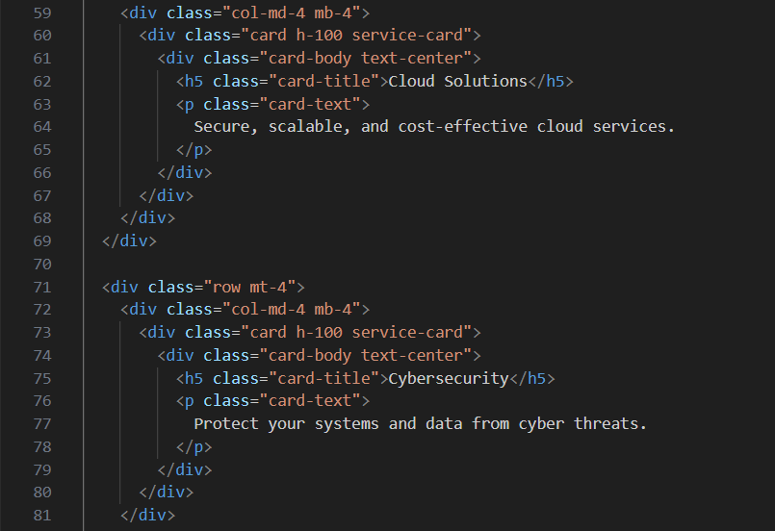
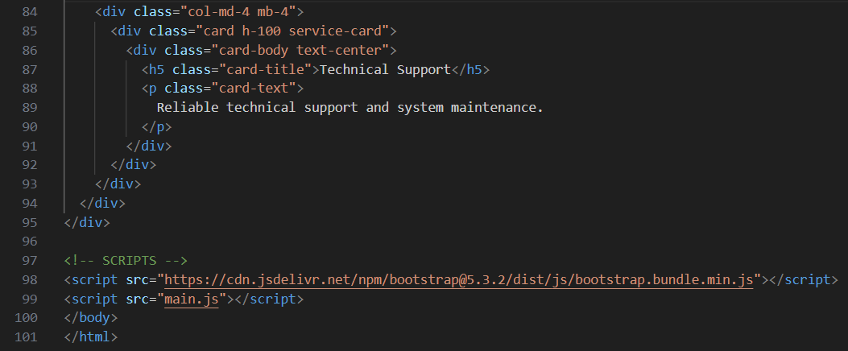
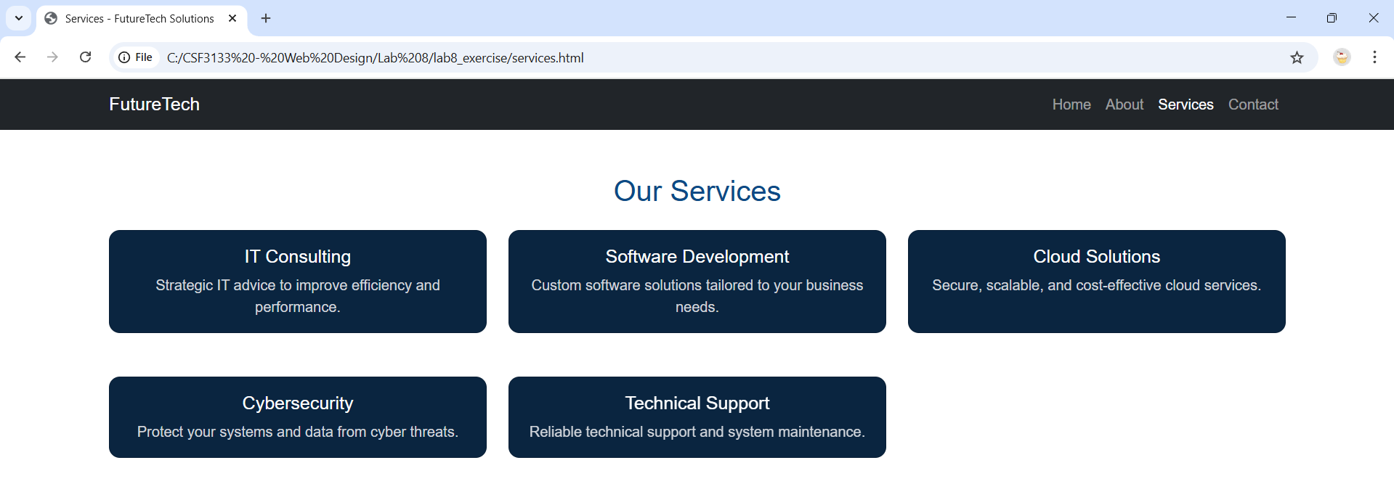
Contact.html
